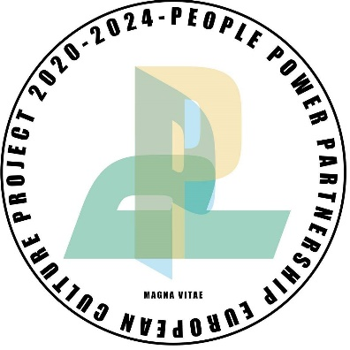

PEOPLE, POWER, PARTNERSHIP
Information Pack

What is People Power Partnership (PPP)?

PPP is a fantastic, physical street theatre project that celebrates the power of young people from 11 countries across Europe with the help of 14 partner organisations.

Each partner will select a group of young adults, from their local area, to work closely with lead partner Pan Optikum (Freiburg, Germany) to develop a spectacular street theatre piece with a deliberate focus on socially relevant issues.

As one of these partners, we (Magna Vitae) are looking for 8 passionate young adults, aged 18-30, from the UK to represent Grimsby in Europe.

Sounds interesting but what will we actually be doing?

As part of our team, you’ll come together over a series of weeks, to create a piece of street theatre expressed through hip-hop. Hip-hop culture is built on understanding local political and social issues. Performances will be based on the themes chosen by you and consequently will be unique to Grimsby, its people, and their perspectives on society.

Once all the partners have recruited their teams, then it really gets exciting. Over the next few months, each partner will visit another partner organisation to help them create their hip-hop routine. That means that we’ll be visiting another country and we’ll also host a group, here, in Grimsby!

Each partner will travel to at least four different countries over the course of the project and be part of the European tour in 2023 & 2024.

Do I need any hip-hop skills or experience?

Not necessarily but we will be looking for three things at auditions:

- You can dance - This is a physical theatre project, so you’ll need some movement experience. This can be from a variety of dance techniques, practices and genres including ballet, contemporary, circus, breakdance or even acrobatic experience, anything that shows us you can express yourself using your body.
- You’re confident - You’ll be performing to many large crowds throughout this project.
- You’re a team player - When we reach the finale, there'll be over 100 of you performing together so you need to be able to work well in a group.

We want to fully reflect the communities of Grimsby and we welcome applications from all backgrounds. If you share our enthusiasm for dance and hip-hop culture, we’d love to hear from you.

Are there any costs involved?

Nope! All expenses including travel, meals and props will be covered across the 4-year project. Pretty sweet, eh?

How much time will I have to commit and when is everything happening?

Although this project will run until 2024, you’ll only need to commit a handful of weeks a year. The dates are subject to change but, at the moment, the timeline looks like this:
2021
19-20 November – Auditions in, Grimsby
21 November – Callbacks in Grimsby

2022
7-19 Mar - Visit from Freiburg team
19 Mar - Performance in Grimsby
24 Jul-13 Aug - Rehearsals in Germany
13-16 Sep - Premiere in Germany

2023
July - Performance in Grimsby
August - Performance in Croatia

2024
August - Performance in Latvia
August - Performance in Portugal

What’s in it for me?

So much! This is an epic project, here are a few things you can look forward to:

- You’ll gain real life creative experience that'll look amazing on your CV!
- You'll push the boundaries of your personal practice, develop new dance techniques and learn the skills needed to express your personal views through an art form.
- You'll get the opportunity to network with European creatives and develop industry links as well as learning about other career options within the arts industry.
- You'll perform to audiences all over Europe and boost your personal exposure within the industry locally, nationally and internationally.
- You'll get to travel, be a voice for Grimsby and represent the town across Europe.

Don't fit the age bracket?

If you're not aged 18 – 30 but still want to get involved, please drop us an email. There’ll be some roles for you coming up soon, so keep an eye on our website and social media.

Sounds right up my street, how do I apply?

You can read more about the audition process and sign up by visiting our website. There’s also a frequently asked questions section on there too, but if you have any other questions or concerns, please feel free to email us.

WEBSITE www.pppgrimsby.co.uk
EMAIL ppp@mvtlc.org
INSTAGRAM @pppgrimsby // @people_power_partnership
FACEBOOK PPP Grimsby // People Power Partnership
TWITTER @pppgrimsby

_____________

The project is co-funded by Creative Europe and North East Lincolnshire Council’s Cultural Development Fund. The Department for Digital, Culture, Media and Sport funds the Cultural Development Fund which is administered by Arts Council England.

All dates are subject to change in accordance to COVID restrictions and safety advice. We are eager for this project to go ahead but we want to keep everyone safe, therefore, changes to the schedule are likely to occur.

