REQUEST for QUOTATION

Event Safety Manager

People Power Partnership
‘Big Production’ 2023

Issue Date: 20 October 2022

Return Date: 5pm on 30 November 2022

Contents

1.0 BACKGROUND 3
1.1 Magna Vitae Trust for Leisure & Culture (MVTLC) 3
1.2 People Power Partnership 3
2.0 SPECIFICATION 5
2.1 Key dates 5
2.2 Description of services required 5
2.3 Main Duties 5
2.4 Contracts and Relationships 8
2.5 Person Specification 8
3.0 TIMETABLE FOR APPOINTMENT 9
4.0 MONITORING ARRANGEMENTS 9
5.0 SUBMISSION OF QUOTATION 10
6.0 QUOTATION 10
7.0 SUPPORTING INFORMATION 11
7.1 Company/Persons Details 11
7.2 References 11
7.3 Proposed Working Methods 12
7.4 Any Other Information 13
8.0 SUPPLIER DETAILS AND DECLARATION 14

1.0 BACKGROUND

1.1 Magna Vitae Trust for Leisure & Culture (MVTLC)

As a Charitable Trust our mission is to provide an extraordinary range of cultural, leisure and health related facilities and services that allow local people to lead a great life. We want to enable more people to be physically and culturally active, more often.

1.2 People Power Partnership

People Power Partnership (PPP) is a 4-year physical theatre project that celebrates the power of young people from 11 countries across Europe with the help of 14 partner organisations. The project is led by German dance company, Aktionstheater PAN.OPTIKUM, the project is co-funded by North East Lincolnshire Council and Creative Europe, and Magna Vitae are the only UK partner.

The first year of the project involved 2 groups of dancers – from Germany and the UK – working together to create a bespoke performance piece that showcased in Grimsby in March 2022.

The second year involved all dance teams travelling to the project leaders HQ (Germany) to create and premiere a large-scale outdoor performance piece.

Years three and four involve touring the larger production around each partner. This includes a performance in Grimsby in July 2023 where 32 dancers from Grimsby, Latvia, Croatia and Portugal will perform together on an outdoor stage with a large angled mirror above. Projection also plays a major role in this performance.

Here are some images from the Premiere in Germany.

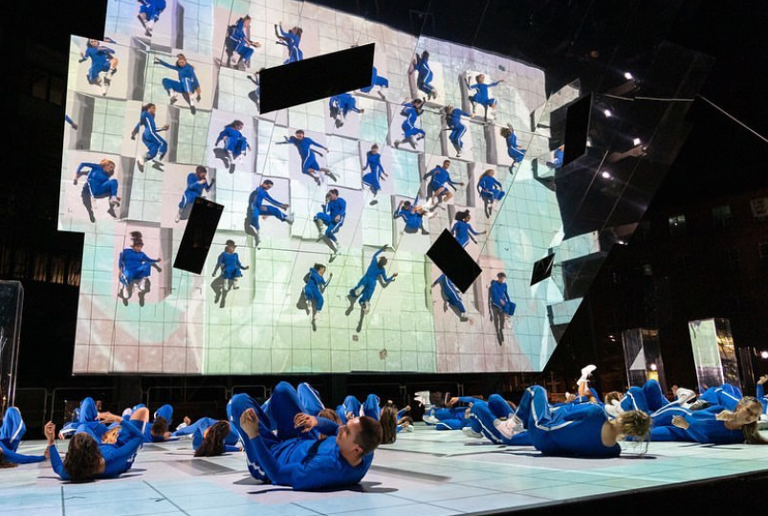

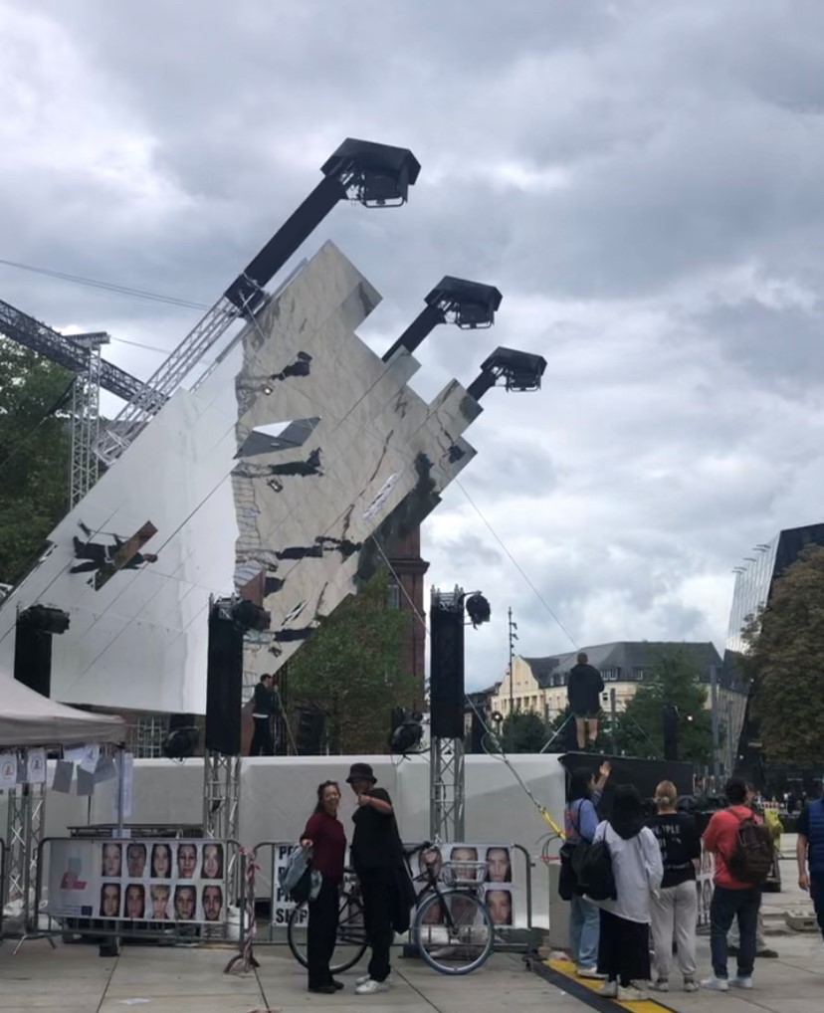

For further information about People Power Partnership, please visit the website;
www.pppgrimsby.org

2.0 SPECIFICATION

This call out is for year three activities only.

2.1 Key dates

- Build starts on Monday 17 July 2023
- Stage, mirror, sound and lights set up by end of day Monday 17 July
- Day time and after dark rehearsals Tuesday 18 – Friday 21 July
- Projector and lighting programming after rehearsals Tuesday 18 – Friday 21 July
- Dress rehearsal evening of Friday 21 July
- Live performance evening of Saturday 22 July
- Dismantling starts after show and throughout Sunday 23 July

2.2 Description of services required

To provision of Event Safety Manager for PPP 2023.

The core function is:
- to advise the Event Management Team on health and safety requirements for incorporation into planning for the rehearsals and performances
- to develop an Event Management Plan for the event
- to liaise with the Safety Advisory Group leading up to the event
- to provide a constant presence during the event to ensure the safety of both staff, crew, performers and the public at all times
- to ensure plans, procedures and activities are compliant with all relevant health and safety legislation and good practice guidance leading up to and during the rehearsals and performances.

The Event Safety Manager’s responsibilities are to include, but not limited to, the following:

2.3 Main Duties

Pre-Event – Planning Stage
- to provide professional advice and guidance to the Event Management Team on all health and safety aspects/requirements for the event, including site visits as required
- to prepare a full and detailed, suitable and sufficient, Event Management Plan for the event, to include:
  - an event safety policy statement detailing the organisational chart and levels of safety responsibility;
  - detailed event risk assessments as appropriate;
  - full details of the event venue design, structures (including documentation in line with the Construction Design Management Regulations 2015), audience profile and capacity, duration, food, toilets, refuse, water, fire precautions, first aid, special effects, access and exits, music levels, etc;
  - a site safety plan detailing the site safety rules, site crew managers and safety co-ordinator, structural safety calculations and drawings;
  - a crowd management plan detailing the numbers and types of stewards, methods of working, chains of command;
  - a transport management plan detailing the parking arrangements, highway management issues and public transport arrangements;
  - an emergency plan detailing action to be taken by designated people in the event of a major incident or contingency;
  - first-aid plan detailing procedures for administering first aid on site and arrangements with local hospitals
  - COVID contingency plan
- to ensure that all plans and procedures are strictly complaint with relevant health and safety legislation, and in line with guidance publications such as ‘The Purple Guide’
- to provide specialist advice and guidance on high risk areas including temporary demountable structures, working at height and use of fireworks/pyrotechnics.
- to liaise with and attend meetings with the Event Management Team on an agreed schedule to discuss plans for the event and to advise on requirements.
- to provide full risk assessments for all elements of event and monitor these to ensure actions are taken and controls adhered to.
- to review and sign off all risk assessments and method statements provided by contractors or third parties including:
  - for specific performances
  - fire risk assessments
  - venues
  - general entertainers/performers
- to check certification supplied by third parties relating to structures and electrics
- to review findings of risk assessment and to present regular updates to the Event Management Team
- to liaise with and attend meetings of the Safety Advisory Group (SAG) to update and respond to queries about the plans for the event
- To provide recommendation on the suitability of sites, including:
  - in the event of wet weather
  - site specific hazards
  - access and egress (including emergency)
  - temporary structures
- to provide recommendations on the type/number/position of equipment required, including:
  - FFE
  - Staging
  - Structures
  - Temporary lighting
  - Emergency lighting
  - Temporary toilets/showers/washrooms
  - Heras fencing/CCB
- to provide recommendation on the number and function of professional stewarding staff required
- to provide recommendation on the number of additional stewards/volunteer marshals required to compliment professional stewarding staff in managing crowd safety
- to provide recommendation on the number of SIA accredited Security Staff required to ensure the safe protection of equipment and personnel for the duration of the event.
- to provide recommendation on the number and positioning of all first aid personnel/units and paramedic/ambulance teams
- to obtain a full medical plan for the event from the medical provider
- to liaise with relevant authorities and agencies as required

During the Event
- to ensure legislative and statutory obligations are implemented and complied with at all times
- to undertake health and safety inspections during rehearsals, build up, the performances and take down
- to ensure that all electrical installations, wiring, switch gear and generators are installed in a safe manner by a qualified electrician and that electrical safety checks have been carried out prior to use
- to ensure that temporary structures adhere to the ‘National Outdoor Events Association Code of Practice for Outdoor Events’, the Institution of Structural Engineers guidance ‘Temporary Demountable Equipment’ and documentation in line with the CDM 2015 Regulations.
- to ensure the safety of crew, performers and public for any performance or displays
- to be contactable/on site at all times during events
- to ensure high risk areas such as the use of fireworks/pyrotechnics and working at height are carried out safely and in accordance with relevant legislation and good practice
- to ensure that FFE provision is sufficient and suitable
- to ensure all equipment is fit for purpose, appropriately sourced and maintained
- to ensure that all personnel and stewards use appropriate PPE as required
- to liaise with the Event Management Team, contractors and suppliers during build, rehearsals, and during the event to ensure the event is safely managed
- to ensure that the Event Management Plan and associated documentation is strictly adhered to
- to ensure the safety of public attending the events including:
  - monitoring crowd movement
  - identification of crowd safety issues
- to attend all briefings for personnel on the events and input as required
- to liaise with Event Control during the events to report on any health and safety issues and action required/taken
- to take action and coordinate the response in the event of a fire or other emergency /incident that arises
- to investigate minor accidents and incidents and report findings to the Event Management Team
- to ensure that all accidents, incidents and near misses are responded to, recorded and reported to the Event Management Team and provide recommendations if any further action is required
- to liaise with Magna Vitae’s Health & Safety advisors over any RIDDOR reportable accidents
- to liaise with the appropriate investigating authorities in the event of serious accidents or incidents.
- to ensure safe evacuation of the public and performers if required during the event in the case of an emergency
- to liaise with and instruct all security, stewards and marshals throughout the duration of the elements of the event
- to be responsible for making decisions during the event if required in the event of needing to postpone or cancel all or part of any performance if there is any health and safety risks that are not managed.

Post Event
- to provide a written report to the Event Management Team detailing:
  - the effectiveness of the Event Management Plan
  - accidents, incidents and near misses
  - lessons learnt and recommendations for future events

2.4 Contracts and Relationships

The Event Safety Manager will work alongside the Event Management Team throughout the planning stages of the event.

Leading up to and during the event, the Event Safety Manager will also work with external agencies, performers and suppliers/contractors working for Magna Vitae, North East Lincolnshire Council and other parties providing elements of the event to ensure the safe running of the event.

2.5 Person Specification

Behaviour/Skills
- Competent risk assessor and sensible approach to risk management in event safety, ensuring documentation (including build, duration and breakdown) is clear, relevant, comprehensible and implementable
- Manages time effectively and delivers against agreed objectives
- Excellent communication skills, both written and verbal
- Excellent interpersonal skills
- Evidence of continuous learning
- Ability to deal with difficult and challenging situations

Qualifications
- NEBOSH General Certificate or Diploma in Event safety Management or equivalent.
- IOSH Managing Safely in the Exhibitions & Events Industry or equivalent
- Evidence of additional Health & Safety training attended (e.g. Manual Handling, Crowd Dynamics, Temporary Demountable Structures, Working at Heights, etc).
- Evidence validating commitment to continuous professional development.
- Note: other relevant qualifications may be considered

Experience
- A minimum of 5 years experience working in the events industry/environment.
- Evidence of promoting a positive Health & Safety culture and improved Health & Safety performance.
- Evidence outlining experience in developing effective solutions to resolve health and safety issues.
- Evidence of developing and maintaining procedures and systems for investigating, reporting and analysing, risks, accidents, incidents, dangerous occurrences and other safety matters and giving advice on preventative and remedial actions where appropriate to eliminate/minimise safety hazards.
- Experience or clear knowledge and understanding of undertaking health and safety audits, inspections or reviews.

Knowledge/Understanding
- Knowledge and understanding of primary health & safety legislation, regulations and codes of practice pertaining to events (e.g. Manual Handling, Temporary Demountable Structures, Working at Heights, Noise, etc).
- Understanding of and ability to undertake and apply risk assessments.

Communication
- Ability to build and facilitate strong working relationships with management, employees and contractors at all levels.
- Strong written and verbal communication skills (e.g. report writing, briefing and presentation skills).

Personal Qualities/Skills
- A confident and effective problem solver and decision maker.
- Self-disciplined with the ability to manage own time, work under pressure and deliver results to tight deadlines.
- Influencing and persuading skills.
- Access to a car or means of mobility support (if driving, possession of a current valid driving licence and appropriate insurance).

Adaptability and resilience
- Willingness to adapt positively to change.
- Willingness to adopt a flexible approach to meet the requirements of the job, including attending site out of hours and at short notice to investigate dangerous occurrences, etc.

Other Requirements
- Magna Vitae’s Health & Safety Assessment for Contractors will need to be completed and accepted
- The Event Safety Manager will need to hold adequate professional indemnity (min £1m) and public liability insurance (min £5m)
- Able to start working on the project with immediate effect and to meet the project milestones identified below.

3.0 TIMETABLE FOR APPOINTMENT

Quotation Request sent out | 20/10/2022
Deadline for submission of quotations | 5pm 30/11/22
Potential Interviews | w/c 5/12/22
Contractor appointed | No later than 19/12/22

4.0 MONITORING ARRANGEMENTS

The role of Event Safety Manager for People Power Partnership 2023 will be selected and managed by MVTLC.

MVTLC is not bound to accept the lowest tender or any tender received.

The appointment will be made by exchange of letter and the successful person will be required to enter into a contract with MVTLC.

MVTLC reserves the right to vary the timetable at their absolute discretion.

A Project Team is in place to deliver the event and will oversee the overall project delivery.

The appointed Event Safety Manager may also be expected to consult with additional stakeholders throughout the project. The number of stakeholders and method(s) of engagement will be agreed.

5.0 SUBMISSION OF QUOTATION

Quotations should be submitted electronically no later than 5pm on 30 November 2022 via email to Melissa Hommel & Matthew Archer: ppp@mvtlc.org

It is strongly recommended that you submit well before the deadline to ensure that failure of ICT/Servers/PC/laptop or similar does not result in your submission failing to be received.

Any queries regarding this opportunity should be submitted to Melissa Hommel or Matthew Archer via email.
Quotations must be submitted on this Request for Quotation Document, in Word Format (unless otherwise specified), which must be duly completed and signed where appropriate.
Any costs incurred by the supplier in the preparation and submission of a quotation will be borne by the supplier and not MVTLC.

MVTLC reserves the right not to contract following receipt of quotations.

Request for quotation documentation may vary in detail, but we will:

- Avoid over specifying a requirement.
- Invite a sufficient number of suppliers to ensure fair competition but remove barriers to participation by small suppliers without discriminating against larger suppliers.
- Provide clear documentation.
- Give all suppliers equal opportunities.
- Provide feedback to unsuccessful bidders.

You may seek clarification on any of the points contained in this document, by contacting the named person, at any time prior to the closing date specified above.

When returning your quotations, please ensure that:

- All documentation is properly completed and enclosed.
- The time by which the quotation must be returned is noted.

6.0 QUOTATION

The costs should be broken down into components with a full description of each component and its associated time and costs

Component description | Quantity of Units required | Unit Price (exc. VAT) | Total Costs (£)
VAT
Total Cost (£)

7.0 SUPPORTING INFORMATION

7.1 Company/Persons Details

Company/Persons Name

Registered Office Address

Registration Number

If the Company/Person is a member of a group of companies, give the name and address of the ultimate holding Company.

7.2 References

Please provide details of suitable references, in order that we can contact them to obtain references.

Please provide a contact name, their role at the event, a telephone number, email address and postal address, and indicate if you require the initial contact to be made by you.

Direct
Contact Acceptable (Y/N)
Reference 1
Event name
Contact Name
Role
Telephone
Email
Address
Reference 2
Event name
Contact Name
Role
Telephone
Email
Address

7.3 Proposed Working Methods

Methods of Working

You are required to respond to the questions below.

You may expand the areas provided or provide your responses on clearly crossed referenced sheets.

1.0 | Compliance with the Specification
1.1 | Tell us about your company and or yourself and your ways of working. Please also tell us about any other individuals that will be involved.
2.0 | Evidence of Competency
2.1 | Please provide details of relevant qualifications held both by the company and/ or any individuals.
2.2 | Please detail the previous experience the company or you have in working on projects of a similar nature.

Assumptions

Please detail the assumptions that have been made about the MVTLC management of, and input to, this piece of work, including time commitment.

7.4 Any Other Information

Please indicate here any other information which you consider may be relevant to support your submission.

8.0 SUPPLIER DETAILS AND DECLARATION

I/We the undersigned DO HEREBY UNDERTAKE to provide the services upon and subject to the terms and condition as set out in such Conditions of Contract, Specification, and the pricing and rates contained in the pricing schedule and other documents as are contained or incorporated herein.

Signature*

Date

Supplier Name

Telephone Number(s)

Email Address

*Electronic signatures or typed names are acceptable. In the event that you are successful, you will be required to resign this form with an original signature.

